What are the performance implications?
Exceptions come with a price, and in order to understand some of the issues involved, let's look at the mechanism for handling exceptions. The Java Virtual Machine maintains a method-invocation stack (or call stack) that features a list of the methods that have been invoked by a thread, starting with the first method the thread invoked and ending with the current method. A method-invocation stack illustrates the path of method invocations a thread made to arrive at the current method.
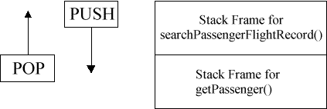
Figure 1. The Java method-invocation stack shows frames for the methods invoked.

Figure 1 shows a graphical representation of the method-invocation stack for our code. Inside the Java Virtual Machine, methods keep their state within the Java stack. Each method obtains a stack frame, which pushes onto the stack when the method invokes and pops from the stack when the method completes. (The stack frame stores the method's local variables, parameters, return value, and other key information needed by the Java VM). As methods continue to complete normally, their frames pop and the stack frame below turns into the currently executed method.
So, for the purposes of our comparison, what needs to happen in Case 1? If a NoPassengerFoundException throws while executing the searchPassengerFlightRecord() method (the top stack frame), further execution of code halts and the Java VM receives control to implement Java's exception-handling mechanism. The Java VM then searches in the current method for a catch clause having NoPassengerFoundException. If it doesn't find such a clause, then the Java VM pops the stack frame for the current method, and the calling method becomes the current method. The Java VM again searches in the current method -- for a suitable catch clause. If the Java VM still doesn't find a suitable catch clause, it pops the current stack frame and then searches the next stack frame for a suitable catch clause, and so on, until it finally finds an appropriate one. Or, if it doesn’t find, then the application terminates with the stack trace printing on the console. Abrupt method completion is significantly more expensive (performance-wise) than a normal method completion.

